MR. DUPREY
Honors Early American History:
Summer Assignment 2017

Honors Early American History is a course that requires students to become proficient in understanding, analyzing, and utilizing primary source documents. Primary source documents allow you to develop your own interpretation of American History. Your summer assignment will prepare you for this challenging, but ultimately rewarding, style of learning history.

Assignment:

*PLEASE MAKE SURE YOU UNDERSTAND THE DEFINITION OF A PRIMARY SOURCE BEFORE UNDERTAKING THIS ASSIGNMENT

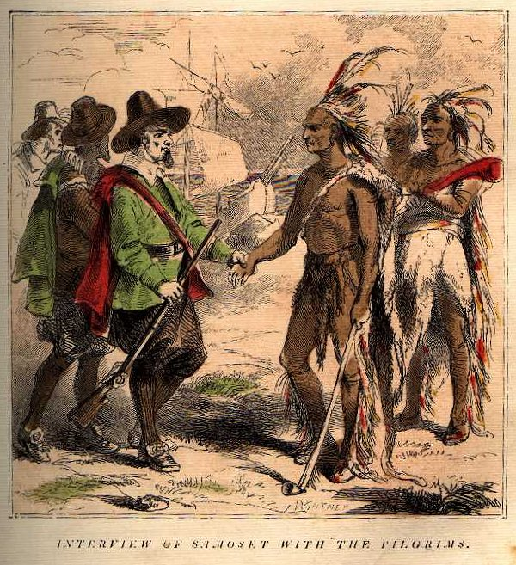
You will research a historical era that we will study in depth next year. More specifically, you are responsible for finding five primary source documents (excerpts are acceptable) from an era of your choice. The sources must exemplify a historical concept, a historical event, a reaction to or perception of a historical event, or other pertinent information.

Then, you will prepare at least two questions for each source that would expect the reader to understand the significance of the document and how it relates to the historical era of choice. These questions should reflect HIGHER level thinking

After each set of questions, you will justify your source choice by explaining in a short paragraph, why that source is relevant to the time period. .

You will be graded according to how well you demonstrate an understanding of the historical era through the document choice and corresponding questions/explanations.

Steps:

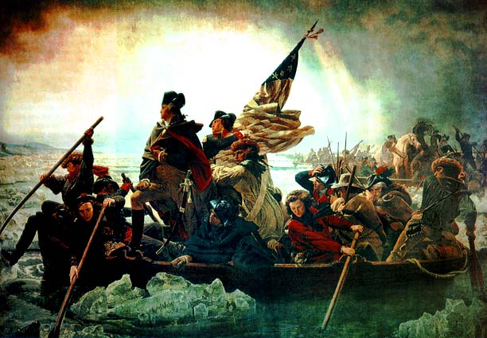
- Choose a historical era from the list below.
- Research your chosen era.
- Study the era in order to understand the important themes, concepts, historical figures, and significant events.
- Research and select five primary or literary sources that relate to the significant information in the chapter. Primary sources can include, but are not limited to charts, graphs, maps, letters, books, speeches, or essays from the chosen time period.
- Formulate questions based upon your understanding of the importance of your historical era.
- After each set of questions, explain why the document was chosen and why the questions are relevant to the important concepts, historical figures, and significant events of the era.

Choose From the Following Eras:
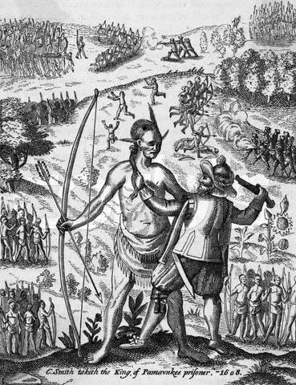
Exploration and Colonization(1500-1700)
Settling the Colonies (1619-1700)
The Road to Revolution the American Revolution (1750-1783)
The Confederation and the Constitution (1776-1790)
Launching the New Nation (1789-1800)
The Triumphs and Travails of Jeffersonian Democracy (1800-1812)
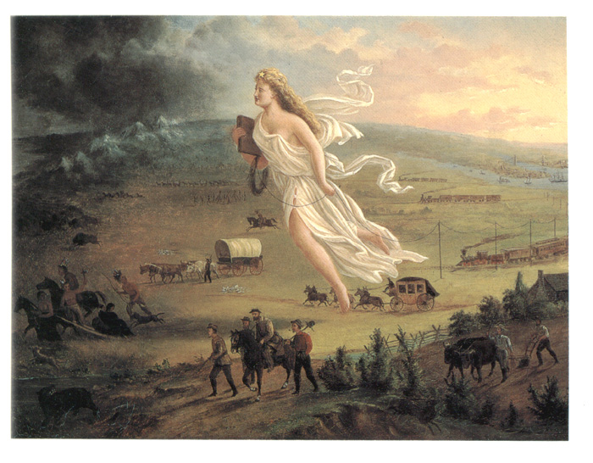
The War of 1812 and the Upsurge of Nationalism (1812-1824)
The Rise of Jacksonian Democracy (1824-1836)
The South & Slavery (1793-1860)
Manifest Destiny and its Legacy (1830-1848)
Drifting Towards Disunion (1854-1861)
The Civil War and Reconstruction (1860-1877)

Tips
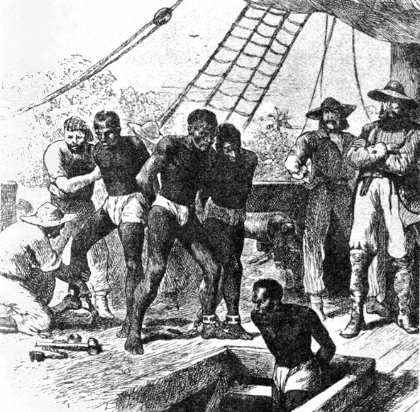
- Choose an era of interest.
- Primary Sources include, but are not limited to, the following: treaties, proclamations, laws, acts, speeches, pictures, political cartoons, newspaper articles, editorials, and letters.
- Sources do not have to be from prominent historical figures. They can also be from average Americans living at the time.
- Vary your sources to make the project more interesting.
- When formulating your questions, keep in mind the significance of the time period and relate the questions to important themes or concepts from the era.
- DO NOT WAIT until the end of summer to rush through this assignment.
- Borrow a textbook from me before leaving for the summer.

If you have any questions, email me at jduprey1110@gmail.com or tweet your question to thedupe68. This project will be due on the first day of school and is mandatory.

Honors Early American History:
Summer Assignments 2009

Grading Rubric
Criterion | Possible Points | Points Earned
Source Variety | 10
Historical Relevance of Sources | 10
Quality of Questions | 10
Document / Sources Justification | 10
Total Score | 40
Comments:

